**LAB 20**

**IPv6 configuration of a Cisco router**

1. Open the file “Lab 20 – IPv6 configuration of a Cisco router.pka” (available on Leho).

It contains the network below. The annotations indicate the IPv6 addresses which need to be assigned.

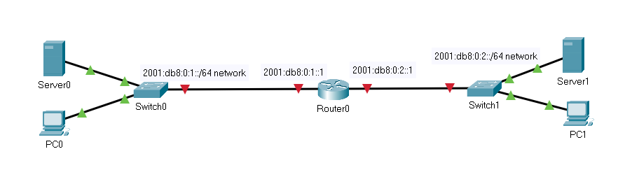

1. Configure the router usingas follows
   1. Give the router your first name.

hostname Stef

* 1. The router must do IPv6 routing (which it doesn’t by default). Use the required command in global configuration mode (see lecture slides).

Ipv6 unicast-routing

* 1. The left interface must be given the designated global IPv6 address.

int GigabitEthernet0/0/0  
ipv6 address 2001:db8:0:1::1/64  
no shutdown

* 1. The right interface must be given the designated global IPv6 address

int GigabitEthernet0/0/1  
ipv6 address 2001:db8:0:2::1/64  
no shutdown

1. Use a command to request the IPv6 addresses of all interfaces on your router.

Show ipv6 int brief

Apart from the GUA addresses you’ve just assigned, which extra IPv6 addresses are automatically created as well?

Global and link local addresses

How is the InterfaceID created of these extra IPv6 addresses?

1. Assign a static IPv6 address to both **servers**. For each server, take the address that follows the address you assigned to the router interface that belongs to their network.
2. Verify that each Server can ping the IPv6 address of the router in its own network.
3. See if you can ping from one server to another.

This will not work as long as you don’t configure the correct default gateway to use by your servers. What is a correct gateway? That is the **link local address** of the router interface belonging to their network!

Set this correctly in both Servers and verify if pinging one server to another succeeds.

1. We configured the servers manually, but now for both **desktop PCs** try to give these a global IPv6 address automatically via **SLAAC**.

Do this via GUI – Desktop – IPv6 Configuration – Automatic . You should see an “Ipv6 request successful” message in that GUI.

(Note: If you don’t automatically get a GUA immediately, go to the subconfiguration mode of the router interfaces and type the **ipv6 enable** command for both interfaces.)

At the command prompt, you can request the IPv6 addresses with **ipconfig** just like on a regular Windows PC.

Which IPv6 address is automatically set as default gateway on the PCs?

The link local address from the router interface that belongs to that network

1. Check if you can ping from PC0 to PC1 based on:
   1. their link local IPv6 addresses

Doesn’t work: the two PC’s are not in the same local link

* 1. their global IPv6 addresses

Works

Explain why this does or does not succeed.

1. Note that the interfaceID part of the IPv6 addresses (both GUA and link local) of the PCs is created based on their MAC address. Explain for the left PC, how the 64-bit Interface ID is created out of the 48-bit MAC address. (See lecture slides.)

Between the 3rd and 4th hexadecimal group, FF and FE were added. This is how we get a 64-bit interface. Also a conversion to the hextet notation is done.

1. Save your PKA file and upload it via Leho.